Experiment VIII
The Bromination of Cholesterol: An Electrophilic Addition Reaction to a Natural Product

Abstract:
The purpose of this experiment was to perform the bromination of cholesterol to form cholesterol dibromide. In this experiment, I performed an electrophilic addition reaction– in specific, a halogenation process called bromination. I started the experiment with 101 mg of cholesterol and ran it through a bromination reaction. Using vacuum filtration to extract the product, I managed to extract 27 mg of cholesterol dibromide, which is a 18.9% yield. With the product, the melting point I observed was 103.6-106°C.
Procedure:
Poulos, Z. J. Organic Chemistry I – A Laboratory Manual for the Health Sciences Major, Fall 2017; Hayden-McNeil: Plymouth, MI, 2017.
Refer to pages 130-134 of the Lab Handbook for the list of equipment used and the full, detailed procedure. I measured and started with 101 mg of cholesterol. The cholesterol was placed into a 10 mL Erlenmeyer flask with 2 mL of MTBE solution. The liquid measurements in this experiment was done a plastic disposable pipette. Instead of using 110 µl of bromine in step 3, we used a disposable pipette and added dropwise into the 10 mL Erlenmeyer flask until it remained a light-yellow color. I used about 7 drops of bromine. For step 6, instead of making the wash solution in a graduated cylinder, it was made in a culture tube. We measured 1.4 mL of HOAc and 0.6 mL of MTBE using a plastic, disposable pipette.

Reactions:
Figure 1. Bromination of Cholesterol via Electrophilic Addition Reaction
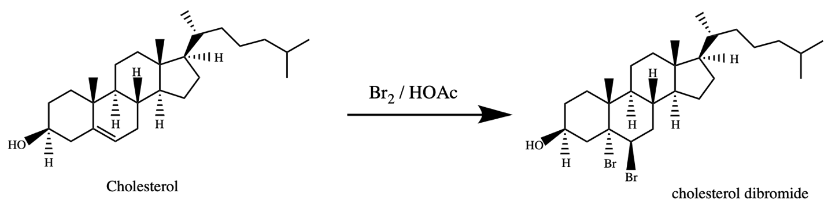

Data/Calculations
Table 1. Recorded and Calculated Values
Mass of Cholesterol Used | 101 mg
Mass of Tared Aluminum Weighing Dish | 416 mg
Mass of Aluminum Weighing Dish with Compound | 443 mg
Mass of Cholesterol Dibromide | 27 mg
Theoretical Yield | 142.74 mg
Percent Yield | 18.9%
Literature Melting Point | 105°C
Observed Melting Point | 103.6 - 106°C

Mass of Cholesterol Dibromide
= (Mass of Aluminum Weighing Dish with Compound) – (Mass of Tared Aluminum Weighing Dish)
(443 mg) – (416 mg) = 27 mg of cholesterol dibromide
Theoretical Yield (Cholesterol Dibromide)
(101 mg Cholesterol) x (1 mmol / 386.66 mg) = 0.261 mmol Cholesterol
(0.261 mmol Cholesterol) x (546.47 mg / 1 mmol) = 142.74 mg of cholesterol dibromide

Percent Yield
(observed mass / theoretical yield) x 100%
[(27 mg) / (142.74 mg)] x 100% = 18.9%
Infrared Spectrum
Figure 2. Infrared Spectrum of Cholesterol
Figure 3. Infrared Spectrum of Cholesterol Dibromide
Discussion
In the experiment, I started with 101 mg of cholesterol and mixed it in a 10 mL Erlenmeyer flask with 2 mL of methyl tert-butyl ether, or MTBE to dissolve it. We then reacted it with bromine using a disposable pipette and adding it dropwise into the 10 mL Erlenmeyer flask. I used 7 drops of bromine until the solution remained a light-yellow color. At this point, cholesterol dibromide started precipitating out of solution in a yellowish-pasty consistency. To extract the precipitate, we performed vacuum filtration and used a wash solution of 1.4 mL HOAc and 0.6 mL of MTBE. This was used to rinse out the 10 mL Erlenmeyer flask while preserving the cholesterol dibromide. The solid was scraped off the filter paper and onto the tared aluminum weighing dish. After letting it dry, the mass of cholesterol dibromide I received was 27 mg. I calculated the theoretical mass to be 142.74 mg, which corresponds to a 18.9 percent yield. Upon testing it, I observed a melting point of 103.6-106°C. Most of the solid melted by the time the machine reached 106°C, which only deviated by the literature melting point of 105°C by less than a degree. This would indicate my precipitate showed little signs of impurity.
The reaction that took place was an electrophilic addition. The alkene double bond in the cholesterol’s 4 membered-ring was broke, creating a nucleophilic attacking spot for the electrophile. The electrophile in this case is the bromide ion. Since the breaking of the double bond creates an area of lower concentration of electrons, as well as a positive charge, the negatively charged bromine attacks that site and bonds in both locations. The two bromides add anti to the cholesterol intermediate.
With a 142.74 mg theoretical yield and a 18.9% percent yield, there must have been error involved in order to account for the loss mass. I only ended up with 27 mg of the product and this could be a result of several procedural errors. Some error occurred when transferring the 101 mg of cholesterol from the weighing paper into the 10 mL Erlenmeyer flask: some of it stuck to the paper or fell onto the table. This would reduce the amount of cholesterol actually involved in the experiment and the amount of cholesterol dibromide formed. I do not believe there was any error involved when adding the bromine solution to the 10 mL Erlenmeyer flask containing the cholesterol and MTBE solution. Regardless of using a disposable pipette rather than an automatic pipette to measure the bromine, the color of the solution in the Erlenmeyer flask remained a light-yellow color after 7 drops. I believed most of the error occurred when washing the precipitate from the Erlenmeyer flask into the vacuum filtration funnel. After using all the wash, there was still visible precipitate that was stuck to the sides of the flask that I was unable to get out. Of course this would reduce the amount of cholesterol dibromide I would observe. Also, during the scraping process, it was especially difficult to get all of the precipitate off of the filter paper and the sides of the funnel. This would also contribute to the loss of cholesterol dibromide. If done again, I would have used more wash solution than said in the protocol in order to get more, if not all, of the cholesterol dibromide from the flask. This would ensure a higher percent yield.
The functional groups in cholesterol are the secondary alcohol and the alkene in the four membered ring. However, since the alkene in cholesterol is symmetrical, there is little to no absorption– or little IR activity. There is a big round curve from wavelengths 3,300 cm⁻¹ to 3,400 cm⁻¹, which corresponds to the alcohol group. It is important to note that although similar, it is not a carboxylic group since carboxylic groups tend to be more broad.
In cholesterol dibromide there is an OH group that responds to the 3,418 cm⁻¹ curve. There are also a series of peaks from 2,948 cm⁻¹ to 2,838 cm⁻¹ which correspond to a C-H stretch. There is a sharp peak at 1,706 which corresponds to an acetic acid group. This would indicate there are impurities, such as acetic acid crystals, in the solid we retrieved. However, since IR is not quantitative, there is no way of measuring how much acetic acid is contained in our product.

